Redistricting plan stirs fears Ulster's power might decline
By Michael Novinson Times Herald-Record

Published: 12:06 PM - 01/28/12
Last updated: 2:18 PM - 01/28/12

Ulster County would double its number of state senators under a proposed legislative redistricting map, but its influence also would be diminished.

Ulster would be the only one of New York's 62 counties to be divided into four state Senate districts. Republicans in the Senate majority diluted the power of liberal northern Ulster by splitting it across so many districts, said League of Woman Voters lobbyist Barbara Bartoletti.

State Sen. Bill Larkin, R-C-Cornwall-on-Hudson, will keep the towns of Marlborough and Plattekill, while state Sen. John Bonacic, R-C-Mount Hope, will keep six towns in southern and western Ulster. The removal of northern Ulster constituents will make each of their districts more safely Republican, Bartoletti said.

The towns of Rochester, Olive, Shandaken and Hardenburgh would be put into an airplane-shaped nine-county district now represented by Otsego County Republican Sen. James Seward.

The Kingston region would become part of the new 63rd Senate District stretching all the way up to the City of Amsterdam in Montgomery County. The district has reportedly been drawn with a possible run in mind for Schenectady County Republican Assemblyman George Amedore.
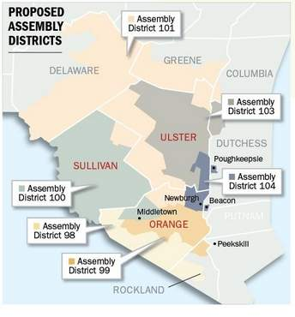

In the Assembly, the Republican-friendly towns of Montgomery, Crawford and Shawangunk have been packed in with GOP-leaning areas of Delaware and Greene counties via a Wawarsing-Neversink connector. No incumbent lives in that district, which was designed by Democrats in the Assembly majority.

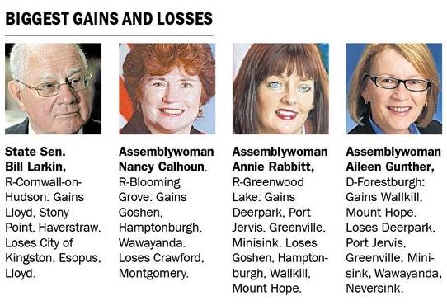

Gov. Andrew Cuomo said Friday that he plans to veto the new district maps, calling the proposal too political and unacceptable.

Rochester Supervisor Carl Chipman said his town will benefit from being moved into an Ulster-majority Assembly district but will miss being part of Bonacic's state Senate district. Having the Rondout Valley split across three Senate districts will also hinder organizations like the Rondout Creek Watershed Council, he said.

Ellenville likes to be paired up with the rest of Ulster County or the historic resort towns of Sullivan County, said Mayor Jeff Kaplan. The proposed Assembly district that includes Ellenville does neither.

"We have enough problems in Ellenville as it is without having to align ourselves with communities who have different needs," Kaplan said.

AD-096, AD-097, AD-098, AD-105

